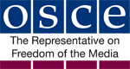
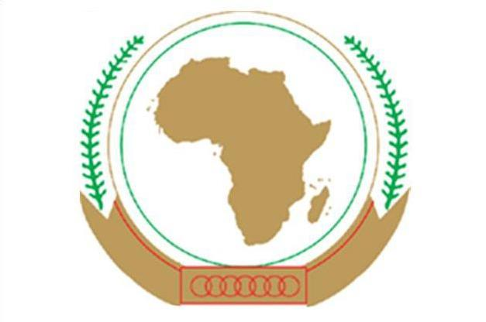
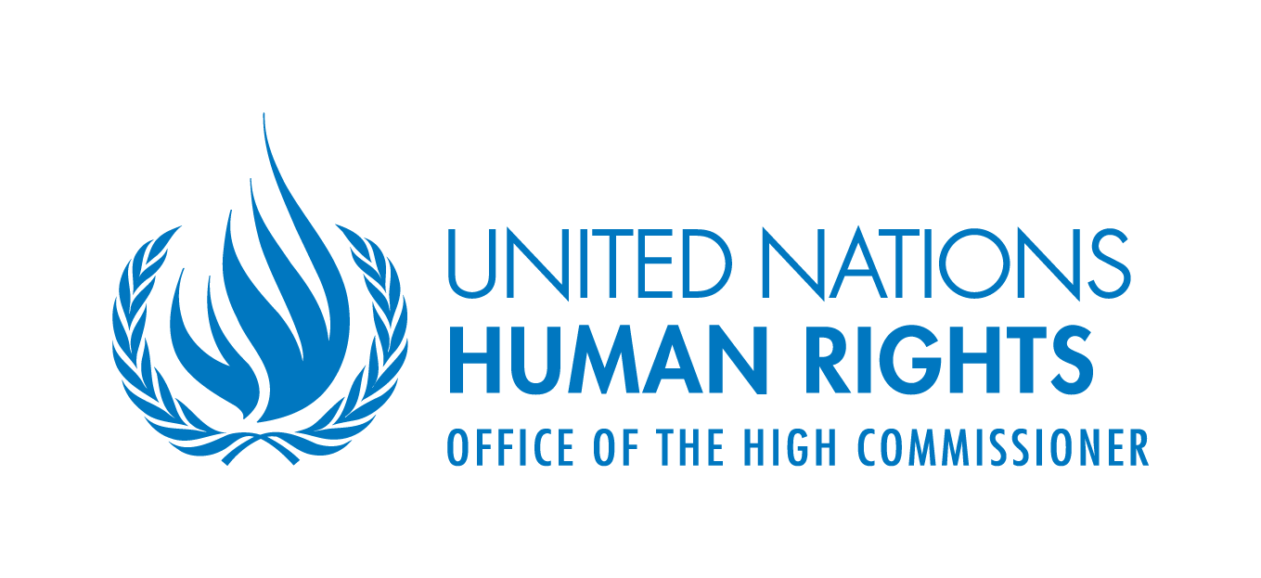
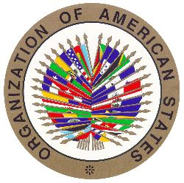

JOINT DECLARATION ON MEDIA INDEPENDENCE AND DIVERSITY IN THE DIGITAL AGE

The United Nations (UN) Special Rapporteur on Freedom of Opinion and Expression, the Organization for Security and Co-operation in Europe (OSCE) Representative on Freedom of the Media, the Organization of American States (OAS) Special Rapporteur on Freedom of Expression and the African Commission on Human and Peoples’ Rights (ACHPR) Special Rapporteur on Freedom of Expression and Access to Information,

Having discussed these issues together with the assistance of ARTICLE 19, Global Campaign for Free Expression, and the Centre for Law and Democracy (CLD);

Recalling and reaffirming our Joint Declarations of 26 November 1999, 30 November 2000, 20 November 2001, 10 December 2002, 18 December 2003, 6 December 2004, 21 December 2005, 19 December 2006, 12 December 2007, 10 December 2008, 15 May 2009, 3 February 2010, 1 June 2011, 25 June 2012, 4 May 2013, 6 May 2014, 4 May 2015, 4 May 2016 and 3 March 2017;

Recognising the essential role that an independent and diverse media, which disseminates a wide range of information and ideas, can play in supporting the functioning of democratic societies, an informed citizenry, the rule of law, participation in public affairs and accountability of public institutions;

Noting that an independent and diverse media can, especially but not only during elections, provide voters with the information they need to make informed choices and promote a level playing field for parties and candidates;

Stressing, in particular, the special role of the media in providing quality, accurate and professionally reported news and current affairs information;

Aware of a range of current threats to media freedom, which include safety, legal, political, technological and economic threats;

Concerned about contemporary legal threats to freedom of expression and the media, including broadening and often ambiguous notions of national security, laws which unduly limit expression online, blocking of websites, the unprecedented number of journalists jailed for their work and the delegation of content regulation to online platforms;

Alarmed at the resurgence of political threats to media independence, such as the abuse of State resources, including advertising, efforts by political figures to capture media outlets and media regulators, withdrawal of accreditation from journalists, harsh attacks which aim to stigmatise and discredit the media, and bans on those who report critically on government, government officials and other powerful social actors;

Concerned about attempts to restrict the independence of public media by governments, politicians and/or officials, thus limiting opportunities for individuals to access to credible and trustworthy news sources which provide a variety of viewpoints;

Deploring ongoing threats to the safety of journalists and others disseminating information in the public interest, including high levels of assassinations, and the persistent impunity for such attacks, both of which undermine media independence and freedom of expression;

Denouncing the special challenges faced by female journalists, including gender-specific attacks, online harassment, inequality within the media and general discrimination against women in society which creates barriers to working as a journalist;

Highlighting that digital technologies, although primarily facilitating freedom of expression and access to information, have also led to new threats such as intrusive forms of State surveillance, de-indexing of content for privacy reasons, challenges such as locating and visibility of information and news disseminated by the media, and the digital divide both within and between countries;

Reiterating our grave concern, noted in the 2011 and 2015 Joint Declarations, that shutdowns and other similar interferences with the Internet are generally unacceptable under international law, in particular in the context of political debate and elections;

Taking note of the importance of public trust in and the credibility of the media, the challenges of maintaining media professionalism in an environment where new forms of media are constantly evolving, and the positive role media self-regulatory and/or co-regulatory bodies can play in this respect;

Alarmed by new threats to the role of free media in democratic societies, including statements by leading politicians that are specifically designed to attack and undermine media independence and the rise of populism;

Emphasizing the important role that investigative journalism can play through exposing corruption and other crimes, including at the international level;

Being aware of economic pressures on the media, including the loss of audience share, especially to social media platforms, and smaller advertising revenues, and the fact that this limits the resources available for investigative reporting, and noting that there is a need to find innovative ways to counter this;

Acknowledging that a lack of transparency of media ownership can promote monopolies and undue concentration of media ownership, and that mergers between media outlets and telecommunications and other types of companies may limit the opportunities for promoting media diversity;

Emphasising the importance of trans-national cooperation between media outlets, including so as to provide quality coverage of issues of international public interest, such as widespread corruption and other practices that undermine democracy worldwide;

Adopt, in Accra, on 2 May 2018, the following Joint Declaration on Media Independence and Diversity in the Digital Age:

- General Principles:

  - States are under a positive obligation to create a general enabling environment for seeking, receiving and imparting information and ideas (freedom of expression), including through the following measures:
    - ensuring that legislation on the right to access information held by public authorities is in place and being implemented;
    - promoting universal access to the Internet;
    - providing appropriate protection for privacy and personal data, including through enabling the anonymous use of digital technologies;
    - ensuring that legislation providing protection to whistleblowers is in place and being implemented; and
    - ensuring that defamation laws are exclusively civil rather than criminal in nature and do not provide for excessive damages awards.

  - States also have a positive obligations to protect media freedom, including through the following measures:
    - enabling a safe working environment for journalists;
    - guaranteeing respect for media independence and, in particular, editorial independence;
    - using a range of tools to promote media diversity, including at the local level and, among other things, through ensuring community media have space to operate on all distribution platforms and adequate resources;
    - refraining from engaging in indirect forms of censorship, such as the abuse of controls over newsprint, radio frequencies or infrastructure used to disseminate media content;
    - ensuring the independence of bodies which exercise regulatory powers over the media;
    - safeguarding the role of independent and sustainable public service media, in particular so as to ensure the provision of high-quality information;
    - guaranteeing the right to protect confidential sources of information, including through protection of source-identifying material such as notes and professional archives in different ways, including through the encryption of communications;
    - respecting freedom of movement, including for both local and foreign journalists; and
    - creating appropriate safeguards against search and seizure of journalistic material.

  - In fulfilling the previous paragraph, any protection for ‘journalists’ rights, including to protect confidential sources, should be based on functional criteria, such as disseminating information and ideas in the public interest, rather than a formal definition of a journalist.

  - States should be particularly scrupulous about promoting and protecting media freedom and independence during elections, including by respecting the right of the media to report freely during election periods and to criticise government policy and political figures subject only to the conditions set out in paragraph 2(a)).

- Threats to Media Safety

  - States are under a positive obligation to provide protection to journalists and others who are at risk of being attacked for exercising their right to freedom of expression, to launch effective investigations when such attacks do occur, so that those responsible may be held accountable, and to offer effective remedies to victims.

- Legal Threats:

  - Restrictions on what may be disseminated through the media should be imposed only in accordance with the test for such restrictions under international law, namely that they be provided for by law, serve one of the legitimate interests recognised under international law, and be necessary and proportionate to protect that interest.

  - States should refrain from adopting unnecessary and/or disproportionate laws criminalising or imposing harsher penalties on online expression than its offline equivalent.

  - Restrictions which are designed specifically for digital communications should be limited in scope to activities which are either new or fundamentally different in their digital forms (such as spamming), and should always respect the standards set out in sub-paragraphs (a) an (b).

  - States should ensure that any regulation of online platforms is in accordance with international standards, including in relation to due process, transparency and the rights to an appeal and remedy. Any liability imposed on intermediaries should be in accordance with international standards and any legal obligation on online platforms to regulate content should also be in accordance with international standards.

  - Administrative rules – for example relating to freedom of movement into States, tax and other financial systems, the designation of ‘protected areas’, and registration and licensing – should establish particularly stringent criteria for their application to journalists and media outlets in order to protect against official abuse and the use of such rules as a pretext to harass the media, and officials should never abuse them in this way.

  - Restrictions on freedom of expression which rely on notions such as “national security”, the “fight against terrorism”, “extremism” or “incitement to hatred” should be defined clearly and narrowly and be subject to judicial oversight, so as to limit the discretion of officials when applying those rules and to respect the standards set out in sub-paragraph (a), while inherently vague notions, such as “information security” and “cultural security”, should not be used as a basis for restricting freedom of expression.

  - Where State media exist, they should be transformed by law into public service media.

- Political Threats:

  - Politicians and public officials should refrain from taking actions which undermine the independence of the media, such as interfering politically in the operations of or taking commercial control over regulatory bodies or commercial, community or public service media, or putting pressure on online platforms to engage in content regulation.

  - It is legitimate for politicians and public officials to criticise, correct or object to specific media reporting but when doing so they should always be careful to ensure that their comments are accurate, avoid stigmatising and discrediting the media, and do not threaten journalists and/or undermine respect for the independence of the media.

  - Respect for the standards outlined above is particularly important during election periods, periods of armed conflict and times of political strife, such as large scale protests.

- Technological Threats

  - States should not conduct surveillance, including of a digital nature, against media outlets or journalists unless this is provided by law and is necessary and proportionate to protect a legitimate State interest.

  - States should put in place effective practical and enforceable measures to avoid identifying confidential journalistic sources indirectly using digital means and should avoid taking actions that result in media outlets or journalists being used as an indirect means to pursue criminal investigations.

  - The removal or de-indexing of online content pursuant to the so-called “right to be forgotten” raises important freedom of expression concerns and States should, if their legal systems provide for this, ensure that these measures are provided for by law in clear, specific terms, are applicable only where the petitioner demonstrates substantive harm to his or her privacy which overrides any freedom of expression interest involved, are subject to appropriate due process guarantees and are otherwise conducted in a manner which, both procedurally and substantively, fully respects the right to freedom of expression.

  - States have positive obligations to take appropriate steps to protect digital communications systems against cyber-attacks and to bolster digital safety and security for those who are at risk of such attacks for exercising their right to freedom of expression.

  - States, online platforms and other interested stakeholders should consider working collaboratively to support an independent, diverse and economically viable media including as a means of responding to the presence of information bubbles/silos.

- Economic Threats

- States should put in place effective systems to ensure transparency, fairness and non-discrimination in access by the media to State resources, including public advertising.

- States should put in place appropriate measures to create an economic environment which supports a diverse media landscape, including legacy media and media serving local and rural communities, and which do not undermine the independence of the media, such as independent or uniform subsidy systems, tax relief.

- States should ensure that all aspects of media markets, including advertising, content production and distribution, operate in a fair and competitive manner which is protected against anti-competitive practices on the part of those holding strong or dominant market positions.

- States should put in place strict requirements of transparency of media ownership, along with effective rules and systems to prevent monopolies or undue concentration of media or cross-media ownership. This should include requiring the approval of independent regulatory bodies before mergers or acquisitions which pose a threat to free competition or diversity can take place and may include limits on the extent of concentration of media or cross-media ownership.

- Media and Online Platforms

- Media outlets and online platforms, as (often) powerful corporate actors, should take seriously their responsibility to respect human rights.

- Media outlets and online platforms should enhance their professionalism and social responsibility, including potentially by adopting codes of conduct and fact-checking systems, and putting in place self-regulatory systems or participating in any existing systems, to enforce them.

- Online platforms should, beyond the minimum legal requirements, operate as transparently as possible, in particular by giving users the tools they need to identify the creators of content and understand its prioritisation (or lack thereof) on their platforms.

- Online platforms should support, in a non-discriminatory and technologically neutral way, the work of the media without unduly influencing that work and while respecting media independence, whether by helping to distribute content, sharing revenue or in other ways.

