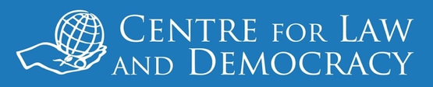

*12 March 2018 – Mexico City, Mexico*

**Mexico: Visit of Sri Lankan and Indian Information Commissioners**

Information Commissioners from Sri Lanka and India undertook a mission to Mexico’s National Institute for Transparency, Access to Information and Personal Data Protection (INAI), the oversight body in that country, last week to exchange best practices and experiences regarding oversight of the right to information. During the technical visit, on 7-8 March 2018, they met with different local actors both within INAI and externally, while on 9March 2018 they participated in a public workshop. The visit was organised by the Centre for Law and Democracy (CLD) with the support of The Social Architects in Sri Lanka, and a former Information Commissioner of Canada also participated.

*“The rich exchanges that took place during this visit will hopefully contribute to the strengthening of each participating commission’s work,”* said Toby Mendel, Executive Director, CLD. *“This visit demonstrates the benefits of South-South knowledge exchanges to building capacity to overcome right to information challenges.”*

During the technical visit, INAI showcased information about its insitutional arrangements and practices. Representatives of civil society and regulated entities in Mexico also shared their persepectives regarding the implementation of the right to information. During the workshop, titled Information Oversight Bodies in North America and South Asia: An Exchange of Views, participants discussed the systemic strengths and weaknesses relating to oversight of to information in each of their countries and shared ideas about how to create truly open public administrations or transparency by design.

***For further information, please contact:***

Portia Karegeya

Legal Officer

Centre for Law and Democracy

Email: portia@law-demoracy.org

+1 4243258650

[www.law-democracy.org](http://www.law-democracy.org)

twitter: @law_democracy