

26 June 2014

Achim Steiner
Executive Director
United Nations Environment Programme
United Nations Avenue
Gigiri PO Box 30552
00100 Nairobi, Kenya
Email: achim.steiner@unep.org

Dear Mr. Steiner,

I am writing on behalf of the Centre for Law and Democracy (CLD), an international human rights NGO that specialises in providing legal and policy expertise to promote foundational rights for democracy, including the right to information.

I would like to express our disappointment with the Access-to-Information Policy issued by UNEP on 6 June 2014 (the Policy). It is now well established within the UN system that the right to access information held by public bodies is a human right, protected, among other things, by the International Covenant on Civil and Political Rights (ICCPR). Given that fact, as well as the overriding importance of transparency and public participation to UNEP’s mandate, as well as the positive statements which UNEP has made in the past on the importance of transparency, we had expected UNEP to adopt a progressive information policy. Unfortunately, the Policy which was adopted falls far short of international standards.

Among the more disappointing aspects of the Policy is its broad and vague regime of exceptions. This starts with Clause 8, the chapeau for the exceptions, which states that UNEP does not

CENTRE FOR LAW AND DEMOCRACY

39 Chartwell Lane
Halifax, N.S.
B3M 3S7
Canada
Tel: +1 902 431-3688
Fax: +1 902 431-3689
Email:info@law-democracy.org

Board of Directors
Lee Cohen
Toby Mendel
Alex Neve
Dawn Russell
Jim Cruikshank

Centre for Law and Democracy
(A company limited by guarantee)

provide access to information where this “could, in UNEP’s opinion, cause harm to specific parties or interests”. This is clearly not an appropriate standard for restricting a human right. Better practice is to allow for restrictions only where disclosure of the information would be likely to cause harm, or preferably significant harm, to a protected interest, which is both a more stringent and a more objective standard.

There are also problems with the specific wording of several exceptions. Clause 9 exempts information not only provided by, but also sent to, third parties “under an expectation of confidentiality”. This effectively creates a third party veto, something that is not recognised in better practice access to information regimes. Instead, these systems protect legitimate third party interests – such as privacy and commercial interests – against harm. These systems also put third parties on notice that their interactions with public bodies come with a presumption of openness. By extending this exception to cover even information sent to third parties under an expectation of confidentiality, UNEP is providing itself with a readymade mechanism for casting a cloak of secrecy over almost all information (i.e. simply by sending it to a third party with a confidential marking on it).

This may be contrasted with the approach taken in the European Investment Bank’s (EIB) 2010 Transparency Policy, Clause 5.2.7 of which states:

As regards third-party documents, the Bank shall consult with the third party whether the information in the document is confidential, according to this policy, unless it is clear that the document shall or shall not be disclosed.

In other words, the EIB will consult with third parties where their interests are engaged but it does not give third parties a veto and will only refuse to disclose information when that information falls within the scope of one of the (harm tested) exceptions in its Policy.

Clauses 13 and 15 are also extremely problematical, together creating a massively overbroad exception for internal deliberations and policy dialogue. The idea that all internal deliberations should be secret is patently contrary to any concept of a human right to information or a presumption in favour of disclosure, as well as established better practice in this area. Instead, these exceptions should protect legitimate interests against harm. Perhaps ironically, the middle sentence of Clause 13 is almost a model of a harm-based exception in this area, unfortunately surrounded by sweepingly broad exception statements. The last sentence, for example, would exclude any communication which contained a “report”. The situation is similar with Clause 15, except here the first sentence is the model and the second unduly broad, excluding, among other things, any communications which “relate to the exchange of ideas”.

Once again, this may be contrasted with the EIB, whose Policy excludes deliberative material “where disclosure would seriously undermine the integrity of the Bank’s decision-making process” (Clause 5.2.5), albeit this is followed by rather less precise wording. All of the problems noted above regarding the exceptions in the Policy run directly counter to the UNEP’s own recommendations to States in this area, the Guidelines for Development of National Legislation on Access to Information, Public Participation and Access to Justice in Environmental Matters (the Bali Guidelines), which state that grounds for refusal should be clearly defined and narrowly interpreted (Guideline 3).

The Policy also falls far short of international standards in relation to appeals. Better practice among IGOs here is to establish both a senior internal appeals body and then an independent external appeals body. The World Bank, the Asian Development Bank and the Inter-American Bank have all created both internal and independent appeals bodies (in the case of the World Bank, the Access to Information Committee and the Access to Information Appeals Board). The UNEP Policy establishes an internal body, the Access-to-Information Panel, made up of UNEP staff appointed by the Executive Director. The Panel is empowered to review appeals against a refusal of information and make recommendations to the Executive Director. This is useful but clearly falls far short of international standards, which mandate an independent review of refusals to provide access, better practice by other IGOs and UNEP’s own ‘Bali Guidelines’, which explicitly call for an independent and impartial oversight body (Guideline 15).

Together, these problems make for a highly flawed access to information policy. However, the Policy is only scheduled to be in place for one year, which provides an important window of opportunity. CLD calls on the UNEP to undertake a comprehensive review of its Policy over the coming year and, in due course, to replace the existing Policy with a strong access to information framework which is consistent with international standards and better practice among IGOs.

Yours sincerely,

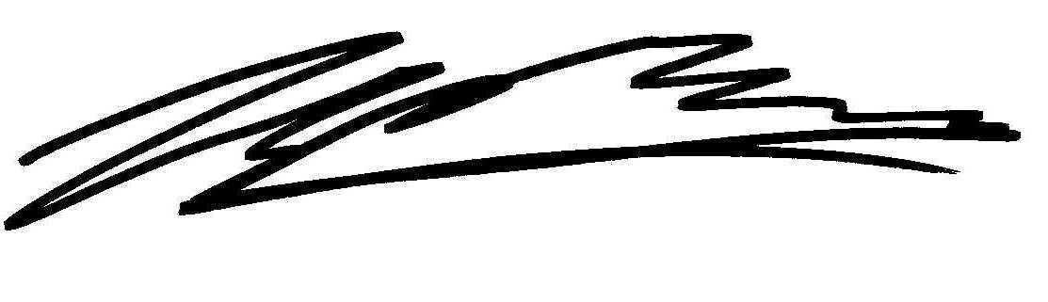
Toby Mendel
Executive Director
Centre for Law and Democracy
toby@law-democracy.org

