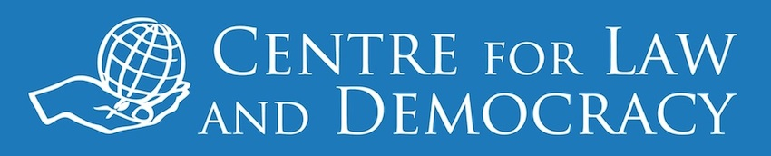

*2 June 2015 – for immediate release*

**Newfoundland and Labrador Enacts Canada’s Best Access Law**

Across the country, Canada’s access to information systems have been stagnating for years with laws that are decades old and hopelessly out of touch with international standards. On June 1, Newfoundland and Labrador broke away from the pack, enacting Canada’s first modern access to information law. The reforms came after a robust consultation and review process, overseen by a high-level Review Committee. The Committee presented its report in March 2015, including draft legislation, and the government moved quickly to implement its recommendations in full.

*“This is a momentous day for the people of Newfoundland and Labrador,”* said CLD Executive Director, Toby Mendel. *“The federal government and other provinces now have no excuse for not giving proper effect to this important right and we call on them to follow Newfoundland and Labrador’s lead.”*

Canada’s Access to Information Act (ATIA) ranks 59th in the world according to the RTI Rating, an internationally-renowned tool for assessing the strength of access legislation developed by CLD and Access Info Europe. The ATI Act only meets around half of the standards in the RTI Rating and Canada’s provinces fare little better. Alberta and New Brunswick’s laws are just as weak as the ATI Act, and Saskatchewan and Quebec score only marginally higher. Newfoundland and Labrador’s new Access to Information and Protection of Privacy Act stands head and shoulders above these laws, and would rank 15th in the world as compared to national legislation.

CLD’s statement on the Committee recommendations and our analysis of the new law using the RTI Rating are available at: [www.law-democracy.org/live/bold-steps-to-improve-the-right-to-information-in-newfoundland-and-labrador](http://www.law-democracy.org/live/bold-steps-to-improve-the-right-to-information-in-newfoundland-and-labrador). Our analysis of access legislation across the country is available at: <http://www.law-democracy.org/live/global-rti-rating/canadian-rti-rating/>.

***For further information, please contact:***

Michael Karanicolas

Senior Legal Officer

Centre for Law and Democracy

email: [michael@law-democracy.org](mailto:michael@law-democracy.org)

tel: +1 902 448-5290

[www.law-democracy.org](http://www.law-democracy.org)

Twitter: @law_democracy