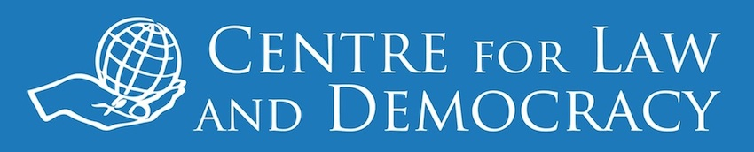

*14 February 2014 – for immediate release*

**Sierra Leone’s Right to Information Law is 5th Strongest in the World**

In October 2013, Sierra Leone became the 96th country in the world, and the 12th country in Africa, to pass an RTI law. An analysis by the Centre for Law and Democracy (CLD) rates the Right to Access Information Act as tied for the 5th strongest in the world. The law scored 124 out of a possible maximum of 150 points on the RTI Rating, an internationally renowned analytical tool developed by CLD and its partner organisation, Access Info Europe, which has been applied to every national RTI law globally.

*“We congratulate Sierra Leone on passing such a strong law,”* said Toby Mendel, Executive Director of CLD. “*The challenge now will be to implement it effectively, something that has been a challenge in many African countries.*”

One of the key strengths of the Act is its broad scope, which covers all types of information held by a wide range of public bodies and even some private bodies. The Act also features strong promotional measures, which will be crucial to its successful implementation. It is also positive that many areas where the Act failed to score points on the Rating could be remedied relatively easily through the adoption of strong regulations.

However, there are also some more serious problems with the Act. These include the lack of a rule ensuring that its access provisions will be interpreted broadly and its exceptions interpreted narrowly, several exceptions which are overly broad, and a failure to provide that its rules trump conflicting legislation to the extent of any conflict.

The RTI Rating result for Sierra Leone is available at: <http://www.law-democracy.org/live/sierra-leones-right-to-information-law-is-5th-strongest-in-the-world/>. For full results of the international RTI Rating, see: [www.rti-rating.org](http://www.rti-rating.org).

***For further information, please contact:***

Michael Karanicolas

Legal Officer

Centre for Law and Democracy

email: [michael@law-democracy.org](mailto:michael@law-democracy.org)

tel: +1 902 448-5290

[www.law-democracy.org](http://www.law-democracy.org)

twitter: @law_democracy