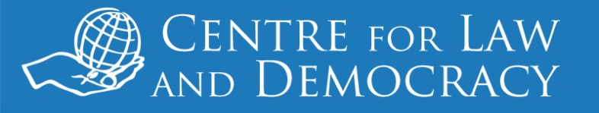

*26 June 2014: For immediate release*

**UNEP: Practise What You Preach**

On 6 June 2014, the United Nations Environment Programme (UNEP) adopted its first ever Access-to-Information Policy, giving individuals a right to access the information it holds. The event was unimpressive not only for its tardiness – the World Bank adopted its first access to information policy in 1994 – but also for the surprisingly weak guarantees in the Policy. The latter not only fail to live up to international standards and better practice by other inter-governmental organisations (IGOs), but also the very standards which UNEP has recommended to States in this area in its *Guidelines for Development of National Legislation on Access to Information, Public Participation and Access to Justice in Environmental Matters* (the Bali Guidelines). CLD has written to Achim Steiner, UNEP Executive Director, calling on UNEP to do better when the current Policy, which has a one-year shelf life, is replaced.

*“To say we were disappointed with the Policy, especially coming from an environmental agency which should understand the value of transparency, is putting it mildly,”* said CLD Executive Director, Toby Mendel. “*Frankly, the hypocrisy of UNEP recommending strong standards for States, which we support, and then adopting such a poor policy itself is hard to understand.”*

A serious problem with the Policy is its vastly overbroad regime of exceptions. The exceptions are almost schizophrenic in nature, with model statements of exceptions being undermined by vastly overbroad statements. The Policy grants third parties a veto over the disclosure not only of information provided by them but also provided to them with an expectation of confidentiality, so that any document UNEP shares which is marked confidential could be covered by the exceptions. Other unfortunate wording in the exceptions would render secret any communication which contained a “report” or which related “to the exchange of ideas”.

The Policy also fails to establish an independent appeals mechanism, in contrast to the approach taken in better practice policies adopted recently by other IGOs, including the World Bank, the Asian Development Bank and the Inter-American Bank.

CLD urges UNEP to take advantage of the year before this Policy expires to conduct widespread consultations with a view to developing a much stronger right to information policy.

The letter is available at: [add URL].

***For further information, please contact:***

Toby Mendel

Executive Director

Centre for Law and Democracy

Email: [toby@law-democracy.org](mailto:toby@law-democracy.org)

Tel: +977 984 1714936

[www.law-democracy.org](http://www.law-democracy.org)

Twitter: @law_democracy