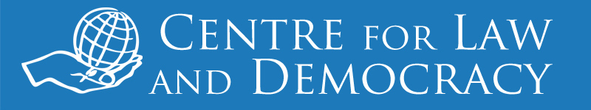

*11 June 2013: For immediate release*

**Morocco: Concerns Remain over Media Law Reform**

Four major draft laws relating to media reform that address the press, electronic press, a national press council and professional journalists are currently being considered in Morocco. Today, the Centre for Law and Democracy released an Analysis which, while noting positive elements in the draft laws, urged that further changes be made before they are passed into law.

Some of the more serious concerns identified include:

* Membership in the National Press Council is mandatory, effectively making the Council a gatekeeper regarding who can be a journalist.
* Moral character and experience requirements are imposed on journalists that represent a bar to joining the profession.
* It is an offence, with the possibility of a significant fine, to criticise foreign leaders or the Moroccan monarchy, or to make statements that harm Islam or Morocco’s territorial integrity.
* Defamation remains a criminal offence, with heavier fines for defaming public officials.
* There is a system for emergency blocking of websites containing defamatory material.

*“We welcome the fact that Morocco is involved in a process of reforming its media laws,”* said CLD Executive Director, Toby Mendel. “*More work is needed, however, to ensure that the laws respect international standards and the right of the media to operate independently.”*

The draft laws were recently the subject of public consultations, including a conference on World Press Freedom Day, 3 May 2013, attended by the Centre for Law and Democracy. CLD has provided comments to the Ministry of Communication, and we urge the government to incorporate our recommendations before the laws are adopted.

The Analysis is available at: <http://www.law-democracy.org/live/morocco-concerns-remain-over-media-law-reform/>.

***For further information, please contact:***

Michael Karanicolas

Legal Officer

Centre for Law and Democracy

Email: [michael@law-democracy.org](mailto:michael@law-democracy.org)

Tel: +1 902 448-5290

[www.law-democracy.org](http://www.law-democracy.org)

Twitter: @law_democracy